Dashboard Specification

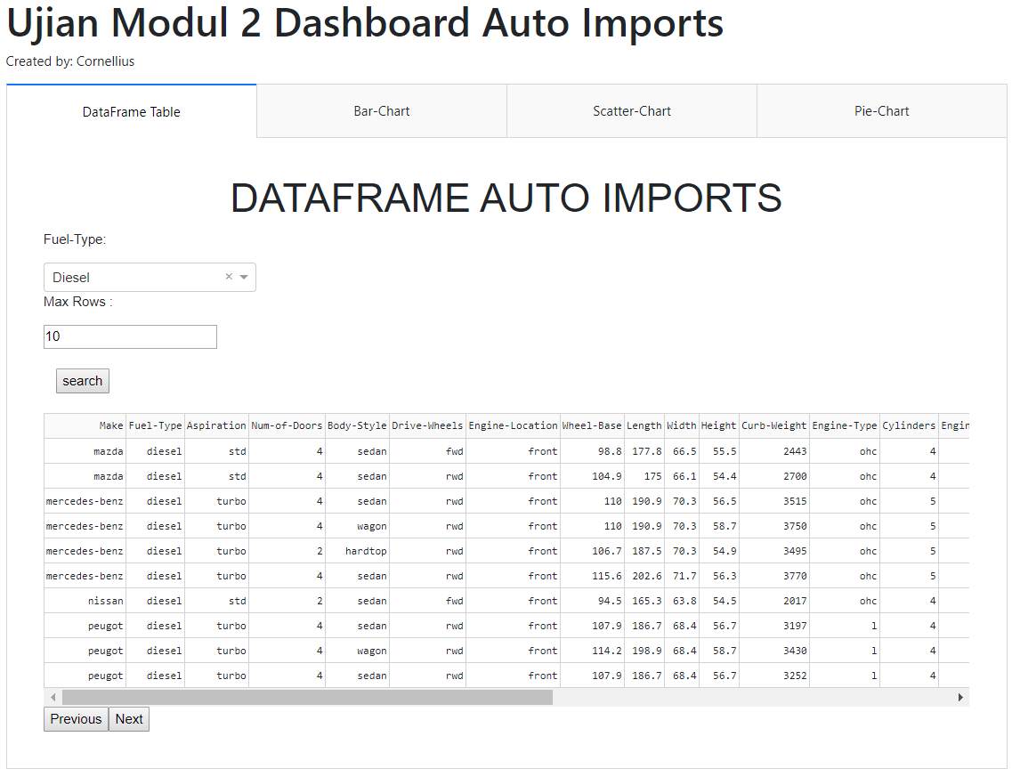
Tab 1 is for the DataFrame Table, we could only filter it based on the Fuel-Type (all the unique value they had). We could also filter it by the Max Rows. To filter, we need to press the Search button first. (hint: If your table is out of bound, just add style_table={'overflowX': 'scroll'} line to the DataTable Parameter.

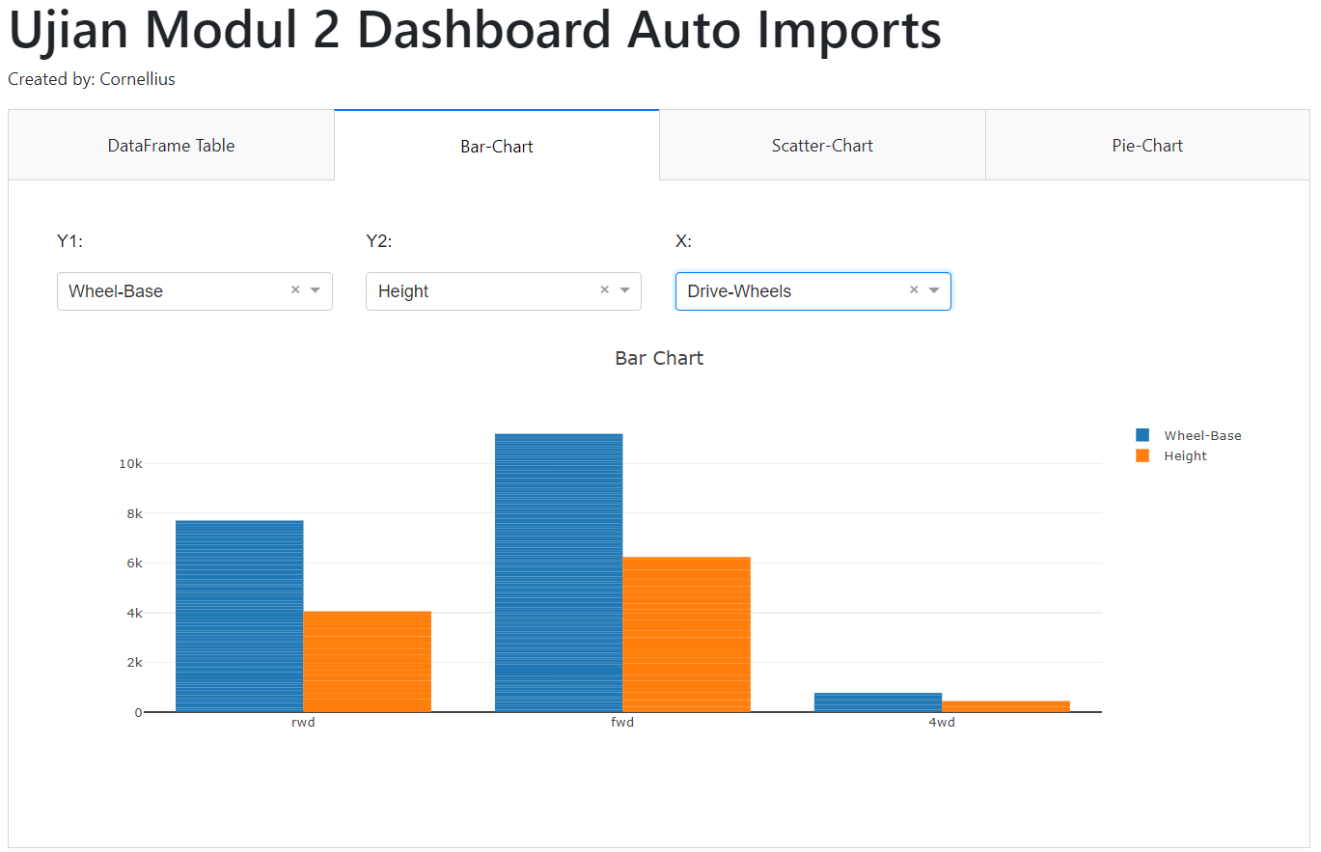
Tab 2 is for the Bar Chart; the Y is all the numerical column in our dataset (Including the new features). Just use the mean as the number for the bar chart. The X is consisting of Drive-Wheels, Engine-Location, Engine-Type
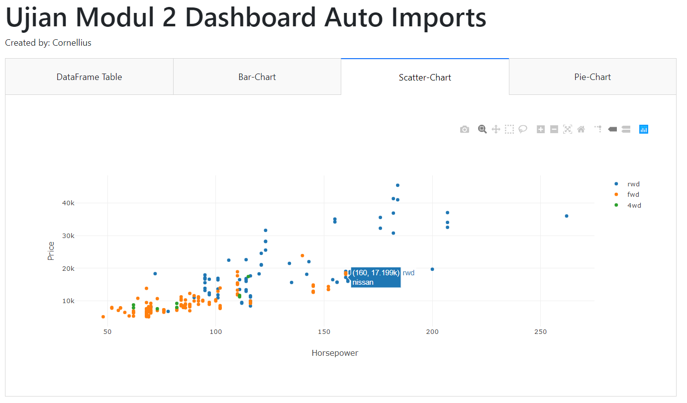
Tab 3 is for the Scatter Chart, just use the X as Horsepower, Y as Price, with the data divided by their Drive-Wheels, and the text is based on their Make.
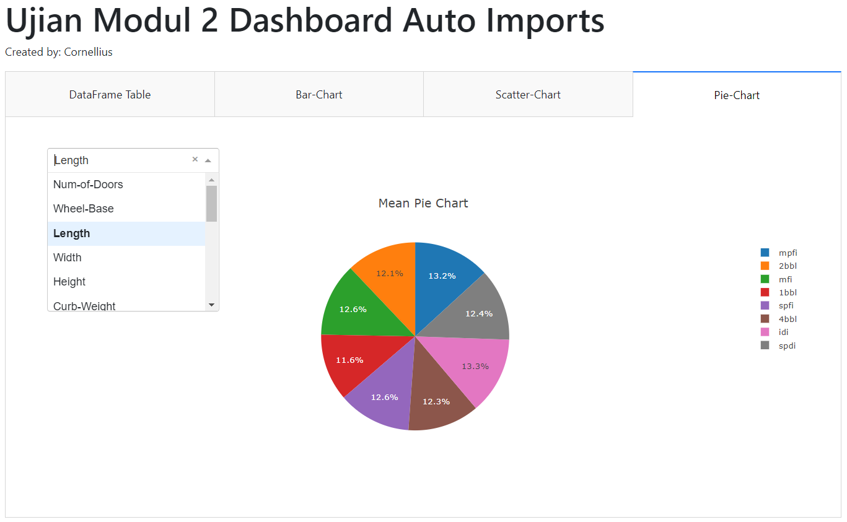
Tab 4 is for the Pie-Chart, which is based on the Fuel-Type and the percentage is come from the mean of the numerical column for each Fuel-Type
Don’t forget the Bootstrap for the layout.

